Package in oracle:

A PL/SQL package in Oracle SQL is a schema object that logically groups related PL/SQL types, items (variables, constants, exceptions), and subprograms (procedures, functions) into a single unit. Packages provide advantages such as modularity, information hiding, and improved performance through shared memory.
Packages consist of two main parts: the package specification and the package body.
Packages in Oracle with Examples
Let’s now take an example to understand what is meant by package and how the package is created and used in Oracle. Before understanding packages let’s try to create a function to calculate square area.
create or replace function square_area
( p_side number )
return number
is
begin
return p_side*p_side;
end;
This function will create a function with square_area which takes one parameter p_side and returns a value that is also a number. The PL/SQL block is the function that just multiplies p_side with itself. Let’s now compile the function.
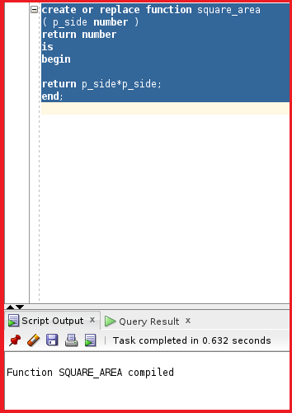
Let’s now check the package by using the select statement and calling the function using the select statement.
select square_area(4) from dual;
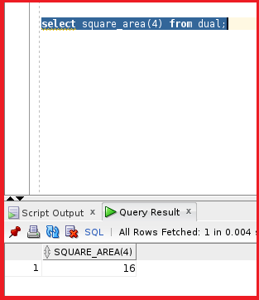
So, we can see the function is working fine. Let’s now create another function named rectangle_area.
create or replace function rectangle_area
( p_l number,p_w number )
return number
is
begin
return p_l*p_w;
end;
From the function we can see the function takes two parameters as the input which returns a number. The logic behind this function is to multiply the length and width and return the value. Let’s go ahead and compile the function.
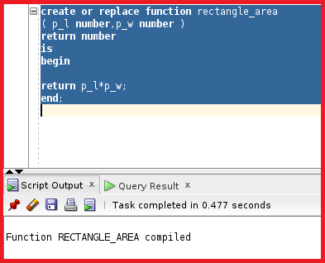
So, the function is now compiled. Let’s try to call this function and see if the function works or not.
select rectangle_area(4,5) from dual;
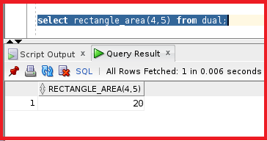
So, the function is working fine. These two functions are related to each other as calculating areas because these two functions are logically grouped. It is better to use a package as the code will be more organized and group logically subprograms.
Let’s now define a package name area in order to create a package we need two parts one is the package and the other is the package body. Let’s see the package specification.
create or replace package area
is
function square_area( p_side number )
return number;
function rectangle_area( p_l number,p_w number )
return number;
--we don’t have begin in package specification
end;
We don’t have the PL/SQL block. The package specification is only for the header part. We have two functions which take square_area and rectangle_area. Let’s now compile this package.
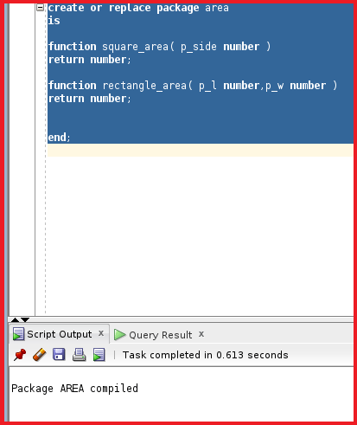
So, the package is compiled. Let’s see the package body specification.
create or replace package body area
is
function square_area( p_side number )
return number
is
begin
return p_side*p_side;
end;
function rectangle_area( p_l number,p_w number )
return number
is
begin
return p_l*p_w;
end;
--the begin is optional--we use it for initilization
begin
DBMS_OUTPUT.PUT_LINE('welcome ');
end;
In the package body, we mention the code for the functions. We have given the package body name as area and we have given the code of the two functions. We have mentioned the function square_area and rectangle_area codes for two functions. We have mentioned the Begin section but the begin section is optional. Let’s go ahead and compile the package body.
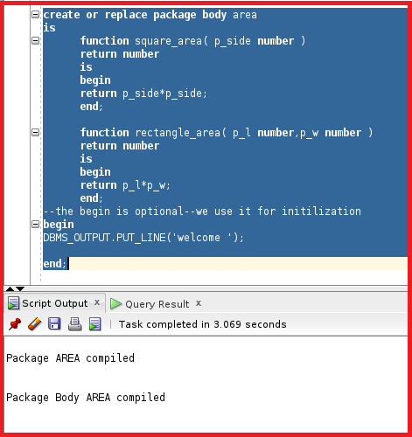
So, packages are divided into package and package body. In the package, we provide the header of the sub-programs and in the package body, we provide the actual code for the sub-programs. Let’s try to check this package by calling the function that is present inside the package.
Select area.square_area(4) from dual;
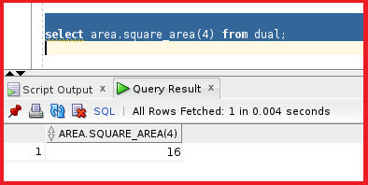
So, the function is working fine. Let’s try another function.
select area.rectangle_area(4,10) from dual;
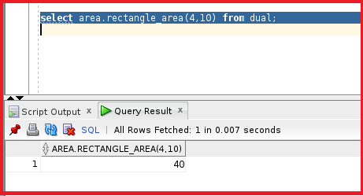
So, the rectangle_area is also working fine. But for these two functions we did not get the DBMS output because when we run the package inside a select statement, we don’t get the DBMS output. But if we use the function between begin and end and by using dbms_output.put_line then the DBMS output will work. Let’s try to test that.
begin
DBMS_OUTPUT.PUT_LINE (area.square_area(4));
end;
So, let’s try to execute this.
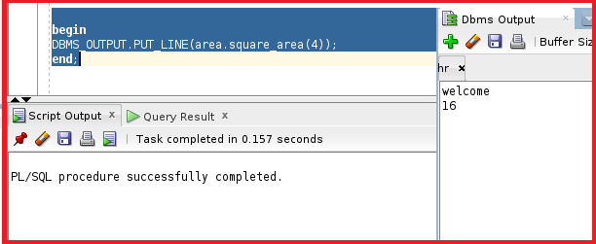
So, we can see the output in the DBMS output. The purpose of the package is to organize the code and work with the SQL statement the way we need it.
What are PL/SQL Packages in Oracle?
A package is a schema object that groups logically related PL/SQL types, variables, and subprograms. We have taken two functions square area and rectangle area. We used these two functions and added them to the package and made it a group logically. Packages are usually two parts:
- A Specification(spec)
- A Body
The specification is the interface to the package. It declares the types, variables, constants, exceptions, cursors, and subprograms that can be referenced from outside the package. The body defines the queries for the cursors and the code for the sub-programs. Enable the Oracle server to read multiple objects into memory at once.
Advantages of using Packages in Oracle:
- Modularity: Encapsulating related constructs.
- Easier Maintenance: Keeping logically related functionality together.
- Easier Application Design: Coding and compiling the specification and body separately.
- Hiding Information: Only the declarations in the package specification are visible and accessible to applications. Private constructs in the package body are hidden and inaccessible. All coding is hidden in the package body.
We will learn all these advantages in the upcoming articles.
Guidelines for writing Packages in Oracle
Now, we will learn about guidelines for creating packages. In order to create the package specification using the CREATE PACKAGE statement we need usually two parts package and package body. While creating the package we have the syntax as below.
Package Specification Syntax in Oracle:
CREATE OR REPLACE PACKAGE package_name IS| AS
Public type and variable declarations
Subprogram specifications
END [package_name];
We have used public type and variable declarations. These are global variables and we use the sub-program specifications to take sub-programs without the code.
- The OR REPLACE option drops and re-creates the package specification.
- Variables declared in the package specification are initialized to NULL by default. We can define the initial value but if the initial value is not declared then it defaults to take a null value.
- All the constructs declared in a package specification are visible to users who are granted privileges on the package. Under a package if we define 5 sub-programs under a schema or user. That user can be able to access all 5 subprograms inside the package.
Package Body Syntax in Oracle:
CREATE OR REPLACE PACKAGE BODY package_name IS| AS
Private type and variable declarations
Subprogram bodies
[BEGIN initialization statements]
END [package_name];
- The OR REPLACE options drop and re-creates the package body.
- Identifiers defined in the package body are private and not visible outside the package body. We cannot reference these variables outside the package body.
- All private constructs must be declared before they are referenced.
- Public constructs are visible to the package body.
Guidelines:
- Develop packages for general use.
- Define the package specification before the body.
- The package specification should contain only these constructs that you want to be public.
- Place items in the declaration part of the package body when you must maintain them throughout a session or across transactions.
- The fine-grain dependency management reduces the need to re-compile referencing subprograms when a package specification changes.
- The package specification should contain as few constructs as possible.
Package Specification:
Procedure insert emp
Procedure update emp_Sal
Procedure delete emp;
Package Body:
Procedure check_before_insert
Procedure check_before_delete
Procedure insert emp
Procedure update emp_sal
Procedure delete emp
Here we create a package for handling user data. We have a procedure for inserting, updating, and deleting tables. Anything apart from this can be created in the package body. We used the same insert, update, and delete but we have added additional procedures like check_before_insert and check_before_delete. We can use the check_before_insert and check_before_delete procedures as private procedures which are not accessible outside the package.
Note: Try to keep package specification as simple as possible and try to add additional codes that need the package body as private subprograms.

How to Create Packages in Oracle?
We will take the real example of using packages. Let’s create a table called student. We will create the columns like student_id, first_name, birthday, and a constraint primary key which is student_id.
create table student
(student_id number,
first_name varchar2(100),
birthday date,
constraint student_pk primary key (student_id)
);
Let’s go ahead and create this table.
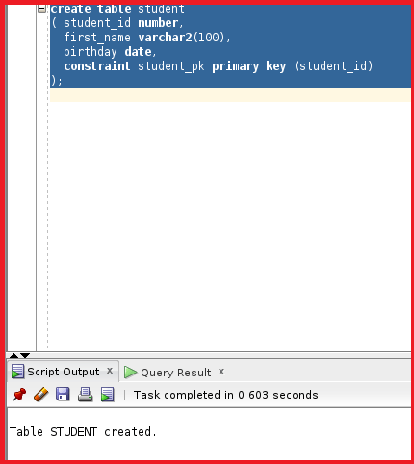
So, the table STUDENT is created. Let’s create a sequence and will use this sequence for insert purposes.
create sequence student_seq;
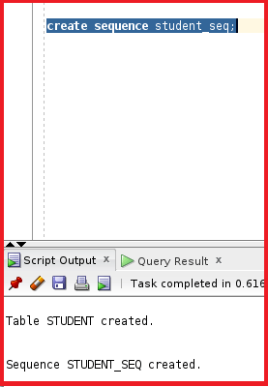
So, the sequence is created. Now, let’s create a package for inserting, deleting, and querying a student. So, the package contains three subprograms.
create or replace package General_student
is
procedure insert_student
(p_first_name varchar2, p_birthday date);
procedure delete_student
(p_student_id number);
function get_name
(p_student_id number )
return varchar2;
end;
From the above package specification, we can see the package name is General_Student where we have three procedure headers. We have a procedure for insert_student with parameters p_first_name with varchar2 and p_birthday with the date as the datatypes. The second procedure is delete_student which takes p_student_id as the parameter where the datatype is a number. The third sub-program is the function that takes the p_student_id as the input and returns the name as the output. Let’s compile the package.
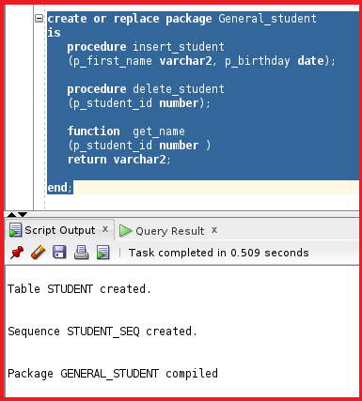
So, the package is created. Let’s go ahead and create the package body.
create or replace package body General_student
is
procedure insert_student
(p_first_name varchar2, p_birthday date)
is
begin
insert into student
values (student_seq.nextval,p_first_name,p_birthday);
commit;
exception
when others then
dbms_output.put_line(sqlcode);
dbms_output.put_line(sqlerrm);
end;
procedure delete_student
(p_student_id number)
is
begin
delete from student
where student_id =p_student_id ;
commit;
exception
when others then
dbms_output.put_line(sqlcode);
dbms_output.put_line(sqlerrm);
end;
function get_name
(p_student_id number )
return varchar2
is
v_name student.first_name%type;
begin
select first_name into v_name
from student
where student_id=p_student_id;
return v_name;
exception
when others then
return null;
end;
end;
We have three sub-programs with two procedures and one function. Let’s go ahead and see each sub-program separately.
Procedure 1:
procedure insert_student
(p_first_name varchar2, p_birthday date)
is
begin
insert into student
values (student_seq.nextval,p_first_name,p_birthday);
commit;
exception
when others then
dbms_output.put_line(sqlcode);
dbms_output.put_line(sqlerrm);
end;
We have the procedure insert_student which takes two parameters p_first_name and p_birthday and inserts them into the table student where the values are the sequence which is considered as the student_id and the first_name and the birthday. We do have an exception that displays if there are any errors.
Procedure 2:
procedure delete_student
(p_student_id number)
is
begin
delete from student
where student_id =p_student_id ;
commit;
exception
when others then
dbms_output.put_line(sqlcode);
dbms_output.put_line(sqlerrm);
end;
The procedure delete_student which takes p_student_id as the input and deletes the records from the table student. This procedure matches the student_id with p_student_id and then deletes the record in the student table. There is an exception column inside the exception.
Function:
function get_name
(p_student_id number )
return varchar2
is
v_name student.first_name%type;
begin
select first_name into v_name
from student
where student_id=p_student_id;
return v_name;
exception
when others then
return null;
end;
The function takes student_id as the input and then selects the first_name from the student table where the student_id=p_student_id and then returns the student_name. There is an exception if there is no data print null. This is the entire package body. Let’s go ahead and compile this package body.
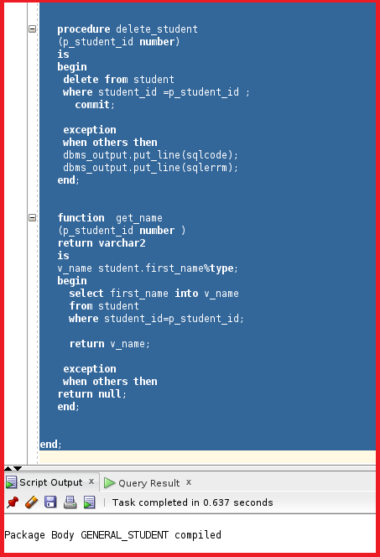
So, the package body is now compiled. So, now let’s test this package.
execute general_student.insert_student (‘Jay’, ’20-Jul-97′);
We are using the insert_student procedure which takes two input parameters. The input takes first_name and birthday.
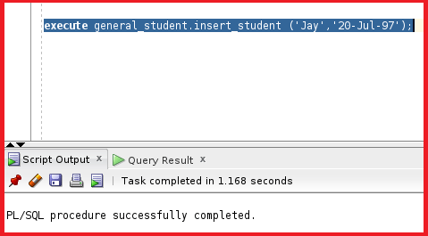
So, the insert_student inside the package is executed successfully. This indicates the records are inserted into the table student. Let’s go ahead and add another record to the table.
execute general_student.insert_student (‘Ram’, ’10-Aug-96′);
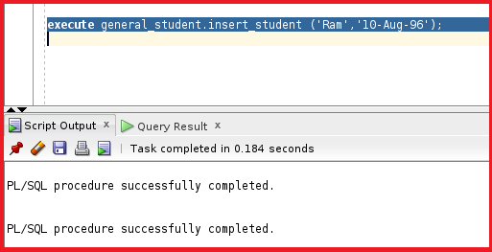
So, the other record is also inserted successfully. Let’s now check the table students.
select * from student;
So, we can see two records that are present inside the table student. Let’s now check the delete_student procedure.
execute general_student.delete_statement(1);
So, the delete_student procedure is executed successfully. We have given the input parameter as 1 which checks for the student_id as 1 and deletes the record with student_id as 1. Let’s now check the table students to see if the record is deleted or not.
select * from student;
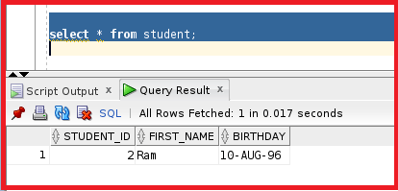
So, the record with student_id 1 is deleted. So, the delete_Student procedure is also working fine. Let’s test the function inside the package.
select general_student.get_name(2) from dual;
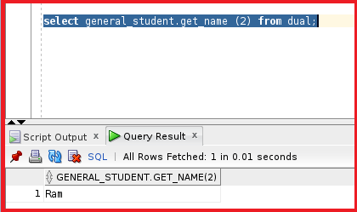
So, we can see the details of the student Ram. The function is also working fine.

